Lab 0: Preparing your laptop for the course – Windows

Four pieces of software are needed to complete this course:
- VMD – Views and analyses molecular models.
- NAMD – Performs molecular dynamics simulations.
- Gnuplot – Plots data
- A modern web browser – Internet Explorer 10 or newer, recent versions of Chrome or Firefox.

Two more are required to make it a more pleasant experience:
- Notepad++ - In fact any text editor rather than word processor will do.
- CoreUtils – Provides some command line tools which make life a lot easier.

We make a couple of assumptions in this document:
- You have admin access (i.e. permission to install new packages to you system)
- You will have a web browser already installed, if you need a more modern version then one is only a web search and standard installation away.

NAMD and CoreUtils require some configuration of the operating system to use them conveniently, but the other software uses standard Windows installation methods.

VMD

Download
Click on this link http://www.ks.uiuc.edu/Research/vmd/ or use your web browser to navigate to the web page.
- Locate the 'Downloads' section
- Click on the 'Download (all versions)' link
In either case you need to select the 'Windows OpenGL' link for the most recent version of VMD (Version 1.9.2 at the time of writing).
- Click the appropriate link
- You now need to register an account
  - Enter a username and password
  - Click ''Continue with registration or download'
  - Fill in the form (including confirming your password)
  - Click 'Register'
- Confirm that you are you and agree to the license
- The download should begin automatically

Installation
- Once the file has downloaded double click on it to run it
- Click 'Yes' when asked to give the program permission to install on your computer
- A standard Windows installer will appear, accept all defaults as they are offered to you and then click 'Install' when the option is presented to you

Notepad++

Download
Click on this link https://notepad-plus-plus.org/ or use your web browser to navigate to the web page.
- Click on the 'download' link on the left hand side of the page
- Click on the big download icon, the correct version should download automatically

Installation
- Once the file has downloaded double click on it to run it
- Click 'Yes' when asked to give the program permission to install on your computer
- A standard Windows installer will appear, accept all defaults as they are offered to you and then click 'Install' when the option is presented to you

NAMD

Download
Click on this link http://www.ks.uiuc.edu/Research/namd/ or use your web browser to navigate to the web page.
- Follow the 'Download NAMD Binaries' link
- Select the Win32 link from the “Version 2.9 (2012-04-30) Platforms” section
  - We use version 2.9 to ensure that all input and output formats are compatible with other software used in the tutorial
- Enter the username and password you created before when installing VMD.
- Agree to the license and the download should start automatically

Installation
- Open the downloaded NAMD_2.9_Win32-multicore.zip file in Explorer
- Copy the NAMD_2.9_Win32-multicore folder
- Paste the folder in a location of your choice (C:\Program Files (x86)\ is a good option)
- Now we need to make the program easily accessible from the command prompt, this involves setting an Environment Variable:
  - Navigate in Explorer into the NAMD_2.9_Win32-multicore folder
  - Left click in the address bar and copy the contents
  - Open Advanced System Settings (Windows 7, 8, 10):
    - From the Start Menu:
      - Click on Control Panel, then System Security, then System, then Advanced System settings
OR
    - Open File Explorer:
      - Type Control Panel\System and Security\System, then click Advanced System Settings
  - Click the 'Environment variables' button. A window like that below should appear.
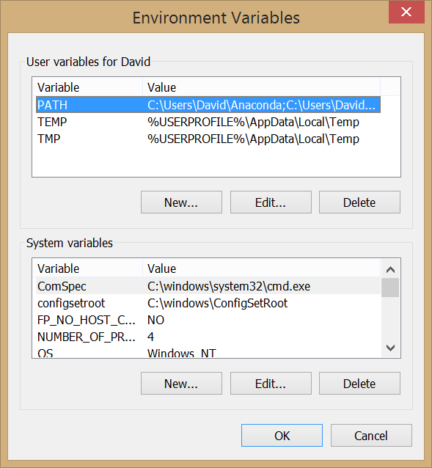
  - Ensure 'PATH' is selected in the 'User variables for xxxxx' listbox and then click the 'Edit' button beneath this section.
  - If there are no entries in 'Variable value' box simply paste in the location you copied earlier:
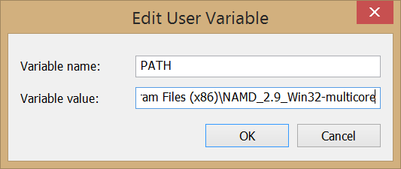
If entries already exist, place the cursor at the end of the text in the box. Enter a ; symbol and then paste in the folder location. So, if the entry read:
C:\Users\David\Anaconda
before it should now say something like:
C:\Users\David\Anaconda;C:\Program Files (x86)\NAMD_2.9_Win32-multicore
  - Click 'OK'.

CoreUtils

Download
Click on this link http://gnuwin32.sourceforge.net/packages/coreutils.htm or use your web browser to navigate to the web page. (If typing that in does not appeal to you, search the web for 'CoreUtils Windows'.)
Go to the 'Download' section of the page and click on the 'Setup program' link, the download should start automatically.

Installation
- Once the file has downloaded double click on it to run it
- Click 'Yes' when asked to give the program permission to install on your computer
- A standard Windows installer will appear, accept all defaults as they are offered to you and then click 'Install' when the option is presented to you
- As for NAMD you now need to set an Environment Variable. Follow the same procedure as before (if you did not change the destination CoreUtils will have been installed in C:\Program Files (x86)\GnuWin32\bin).
  - If you had no Environment Variables set at the start of this process the PATH variable value should now be:
C:\Program Files (x86)\NAMD_2.9_Win32-multicore;C:\Program Files (x86)\GnuWin32\bin

Gnuplot

Download
Click on this link http://sourceforge.net/projects/gnuplot/files/gnuplot/5.0.0/ or use your web browser to navigate to the web page.
- Click on the gp500-win64-mingw.exe link
- The download should start automatically (a short delay is normal)

Installation
- Once the file has downloaded double click on it to run it
- Click 'Yes' when asked to give the program permission to install on your computer
- A standard Windows installer will appear, accept all defaults as they are offered to you, accept the license agreement and then click 'Install' when the option is presented to you
- As for NAMD and CoreUtils you now need to set an Environment Variable. Follow the same procedure as before (if you did not change the destination the program will have been installed in C:\Program Files\gnuplot\bin).
  - If you had no Environment Variables set at the start of this process the PATH variable value should now be:
C:\Program Files (x86)\NAMD_2.9_Win32-multicore;C:\Program Files (x86)\GnuWin32\bin;C:\Program Files\gnuplot\bin

Testing NAMD, CoreUtils and Gnuplot Installations
If the installation has worked then NAMD and all the programs in Coreutils should be available directly from the Command Prompt.
- Open Command Prompt (Windows 7, 8, 10):
  - Using the Search feature:
    - Search for “cmd”
- To test CoreUtils type:
basename --version
  - If CoreUtils is installed and setup correctly message giving the version number and other program details should appear.
- To test NAMD type:
namd2
  - A window bearing an alarmist message may appear, if so click 'Cancel'
  - If NAMD is installed and setup correctly then a message stating:
FATAL ERROR: No simulation config file specified on command line.
- To test Gnuplot type:
gnuplot
  - If Gnuplot is installed correctly a message giving the version of the code should appear and the terminal prompt should look like:
gunplot>
  - Try making a plot by typing:
plot sin(x)
  - Exit by typing:
Exit

To make VMD run from the Command Prompt (optional):
- As for NAMD, CoreUtils and Gnuplot, you need to set an Environment Variable to make VMD available from the Command Prompt. Follow the same procedure as before (if you did not change the destination the program will have been installed in C:\Program Files (x86)\University of Illinois\VMD).
  - If you had no Environment Variables set at the start of this process the PATH variable value should now be:
C:\Program Files (x86)\NAMD_2.9_Win32-multicore;C:\Program Files (x86)\GnuWin32\bin;C:\Program Files\gnuplot\bin; C:\Program Files (x86)\University of Illinois\VMD
  - Try opening VMD by typing:
vmd

Introducing the Command Prompt
Have a quick look at the tutorial in the following link:
http://tutorial.djangogirls.org/en/intro_to_command_line/README.html

Getting the Course Files
All course content is available from:
https://sassie-web.chem.utk.edu/training/aps_2016/main.html
Download each days zip file onto your desktop as you progress.

