The energy minimization speed comparison between OpenMM, NAMD, and MDX

0. General

OpenMM is a library which provides tools for modern molecular modeling simulation. It has the following characteristics:
OpenMM is designed for highly parallel systems. It provides three platforms for simulation: reference, OpenCL, and CUDA. The “reference” platform is designed to serve as reference code for writing other platforms. It is written with simplicity and clarity in mind, not performance. It will always run on single core, and is expected to be slow.
OpenMM is mainly used for MD simulation. The energy minimization step provides users with less options than NAMD and MDX.
OpenMM API only takes the AMBER force field (the NAMD and MDX minimizations in SASSIE are based on the CHARMM force field).
According to OpenMM source code, “permission is granted, free of charge, to any person obtaining a copy of this software and associated documentation files (the "Software to deal in the Software without restriction, including without limitation the rights to use, copy, modify, merge, publish, distribute, sublicense, and/or sell copies of the Software”
The present content compared the energy minimization speed between OpenMM, NAMD and MDX in order to seek more minimization options for SASSIE. Comparison was performed based on three systems (small, medium, and large):
Villin N68H (35 amino acids)
Gag (431 amino acids)
MCM hexamer (3996 amino acids)
The present calculation was performed on two platforms:
OSX Lion 10.7.2 (AMD Radeon HD 6750M 512M)
Gibbs (CUDA-equipped)

1. Tests on a small system (Villin N68H, 35 amino acids)

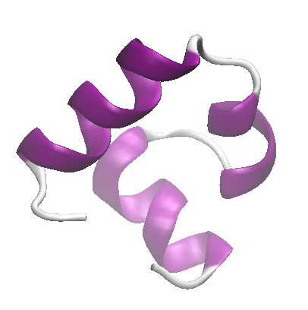
Mutual minimization conditions:
Steps: 1000
Constrains: all bond lengths
Non-bonded cutoff: 10 Å

Additional NAMD minimization conditions:
exclude scaled1-4
1-4scaling 1.0
switching on
switchdist 8
pairlistdist 12
margin 2
rigidTolerance 0.00001
rigidIterations 500

Additional MDX minimization conditions:
exclude scaled1-4
1-4scaling 1.0
switching on
switchdist 8

Results:
Table 1

Conclusions:

- OpenMM (OpenCL on OSX Lion and CUDA on gibbs) and NAMD minimization are fastest and comparable;
- OpenMM (OpenCL on OSX Lion and CUDA on gibbs) minimization is slightly faster than NAMD;
- MDX minimization is slowest.

Note: “MDX-orig” vs “MDX” correspond to the following source code change:
“MDX-orig”: nst='/usr/local/bin/mdsim temp.inp >& junk.out &'
“MDX-”: nst='/usr/local/bin/mdsim temp.inp >& junk.out '

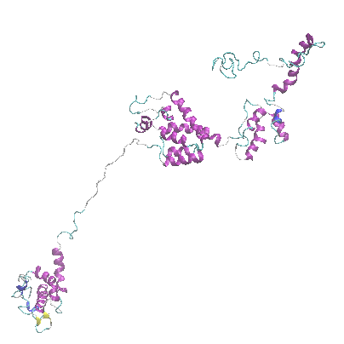
2. Tests on gag (431 amino acids)

Mutual minimization conditions:
Steps: 100
Constrains: all bond lengths
Non-bonded cutoff: 10 Å

Additional NAMD minimization conditions:
exclude scaled1-4
1-4scaling 1.0
switching on
switchdist 8
pairlistdist 12
margin 2
rigidTolerance 0.00001
rigidIterations 500

Additional MDX minimization conditions:
exclude scaled1-4
1-4scaling 1.0
switching on
switchdist 8

Results:
Table 2

Conclusions:

- NAMD, OpenMM (OpenCL on OSX Lion), and OpenMM (CUDA on gibbs) are fastest and comparable;
- MDX and OpenMM-reference minimization are slow.

Note: “MDX-orig” vs “MDX” correspond to the following source code change:
“MDX-orig”: nst='/usr/local/bin/mdsim temp.inp >& junk.out &'
“MDX-”: nst='/usr/local/bin/mdsim temp.inp >& junk.out '

3. Tests on MCM hexamer (3996 amino acids)
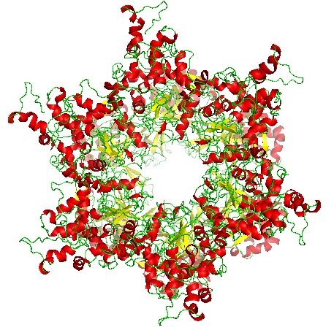
Mutual minimization conditions:
Steps: 100
Constrains: all bond lengths
Non-bonded cutoff: 10 Å

Additional NAMD minimization conditions:
exclude scaled1-4
1-4scaling 1.0
switching on
switchdist 8
pairlistdist 12
margin 2
rigidTolerance 0.00001
rigidIterations 500

Additional MDX minimization conditions:
exclude scaled1-4
1-4scaling 1.0
switching on
switchdist 8

Results:
Table 3

Conclusion:

- NAMD minimization is fast;
- OpenMM-OpenCL and CUDA minimization are slower than NAMD but slightly faster than MDX.
- OpenMM-reference minimization is extremely slow (>5 hrs)

Note: “MDX-orig” vs “MDX” correspond to the following source code change:
“MDX-orig”: nst='/usr/local/bin/mdsim temp.inp >& junk.out &'
“MDX-”: nst='/usr/local/bin/mdsim temp.inp >& junk.out '

OpenMM-reference minimization is extremely slow (>5hrs) and not shown.

Final conclusion:
OpenMM minimization time scales very unfavorably. It is fastest for the smallest system (villin), but very slow for large systems (gag and MCM). It is designed for highly parallel platforms, and consequently, openMM-reference is not feasible for the large systems (MCM) at all. Moreover, considering the less flexibility and AMBER-only restrictions from OpenMM API, currently it is not planned to be incorporated into SASSIE-1.0.

