Monte-Carlo Phase-2 Statement

- Goal
Study to dictate what direction and how comprehensive our Monte-Carlo program will be.

- Method:
  - 0th order: All-atom Monte-Carlo with implicit solvent
  - 1st approximation: Define intrinsic disordered region (IDR)
Worry: Won’t capture desolvation energy and local reorganization

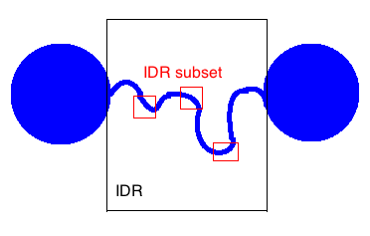

    - IDR: Alter all flexible bond angles, and backbone dihedrals (already implemented in SASSIE-1.0)
IDR may also need to include general dihedrals and improper dihedrals (not implemented yet)
    - IDR-subset: Alter all angles, backbone dihedrals, general dihedrals, and improper dihedrals

- Thesis Statement
For IDR of length N, we need to evaluate the chemical/physical accuracy, sampling efficiency, numerical timing, and overall throughput of our algorithm as a function of our local move basis set. Our move basis set is dependent upon the number of adjacent residues and the depth of basic move types (angles, backbone dihedrals, general dihedrals, and improper dihedrals)

- Strategy
No bonds needed
Needs to consider: angles and all dihedrals Δs (backbone dihedral Δ_{B}, improper dihedral Δ_{I}, and others Δ_{K})
Δs ∈ {Δ_{B}, Δ_{I}, Δ_{K≠B,I}}
  - How important are light atoms containing Δ_{S}?
  - How do we deal with Δ_{I}?
Coarse-Grained single body?
All atom rigid body?
Include them all (allow Δ_{I})?
  - How do we deal with angles?
Same as Δ_{S}?
Are there key angles that are a sufficient set?
Single or concerted moves?

